368 git status

369 git commit -m "FISDevops Batchgit status Yu guys are rockgit statusgit status!" .

370 git commit -m "FISDevops Batchgit status Yu guys are rockgit statusgit status!" .

371 git commit -m "FISDevops Batchgit status Yu guys are rockgit statusgit status!"

372 git config --global user.email mayank

373 git config --global user.name mayank

374 git commit -m "FISDevops Batchgit status Yu guys are rockgit statusgit status!"

375 git push origin main

376 git push origin master

377 git push

378 ls

379 cat index.html

380 cat sehwag.html

381 cat republic.html

387 ls

388 rm -rf *

389 s

390 ls

391 docker run -itd -p 2999:80 httpd

392 docker images

393 docker ps

394 docker exec -it angry_mirzakhani bash

395 docker ps

396 docker cp /root/DevopsFISfiles/* angry_mirzakhani:/usr/local/apache2/htdocs/

397 cd /root/DevopsFISfiles/

398 docker cp * angry_mirzakhani:/usr/local/apache2/htdocs/

399 docker cp index.html angry_mirzakhani:/usr/local/apache2/htdocs/

400 docker cp sehwag.html angry_mirzakhani:/usr/local/apache2/htdocs/

401 docker cp republic.html angry_mirzakhani:/usr/local/apache2/htdocs/

402 cd

403 history

<https://www.jenkins.io/doc/book/installing/linux/#red-hat-centos>

<https://www.jenkins.io/doc/book/installing/linux/#red-hat-centos>

https://www.tecmint.com/install-epel-repo-on-rhel-8/

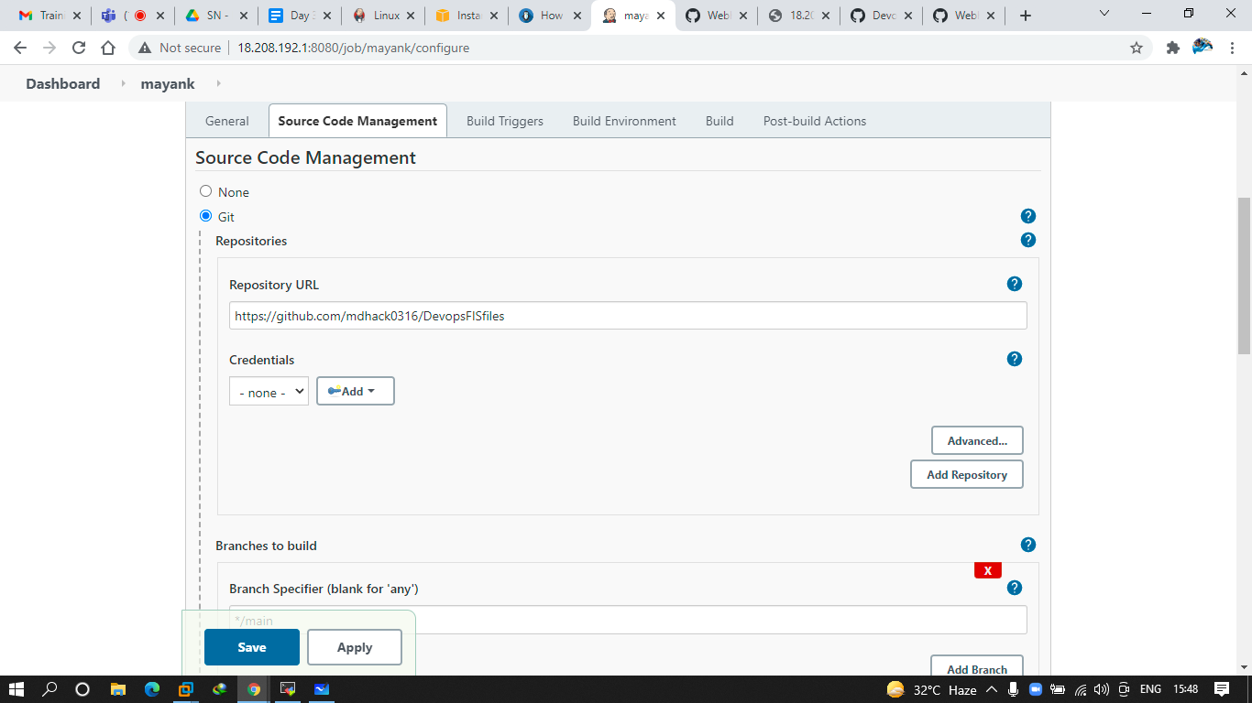

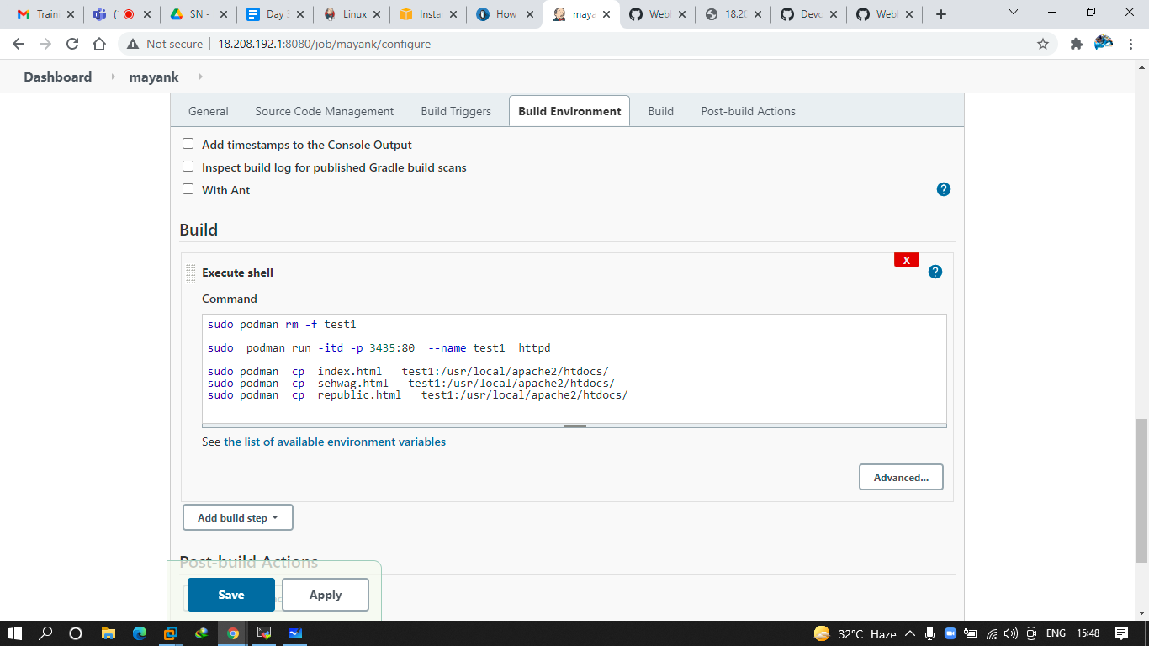

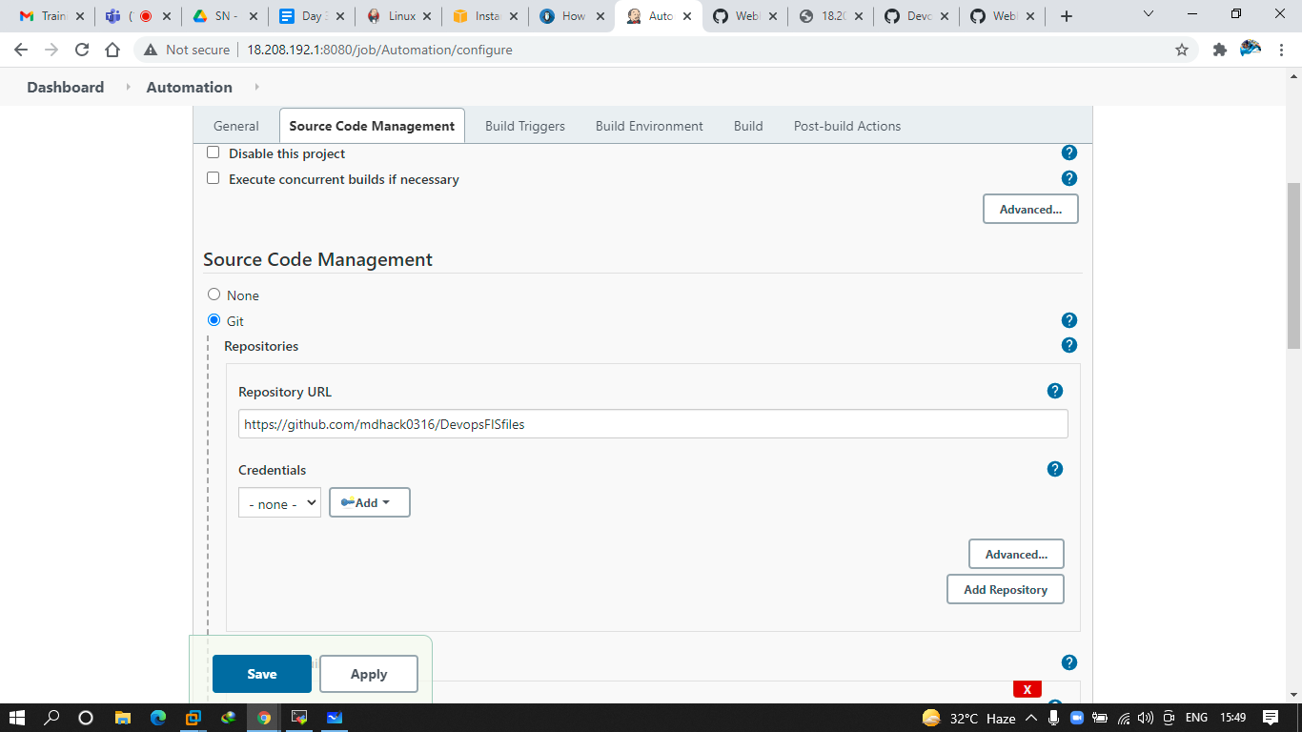

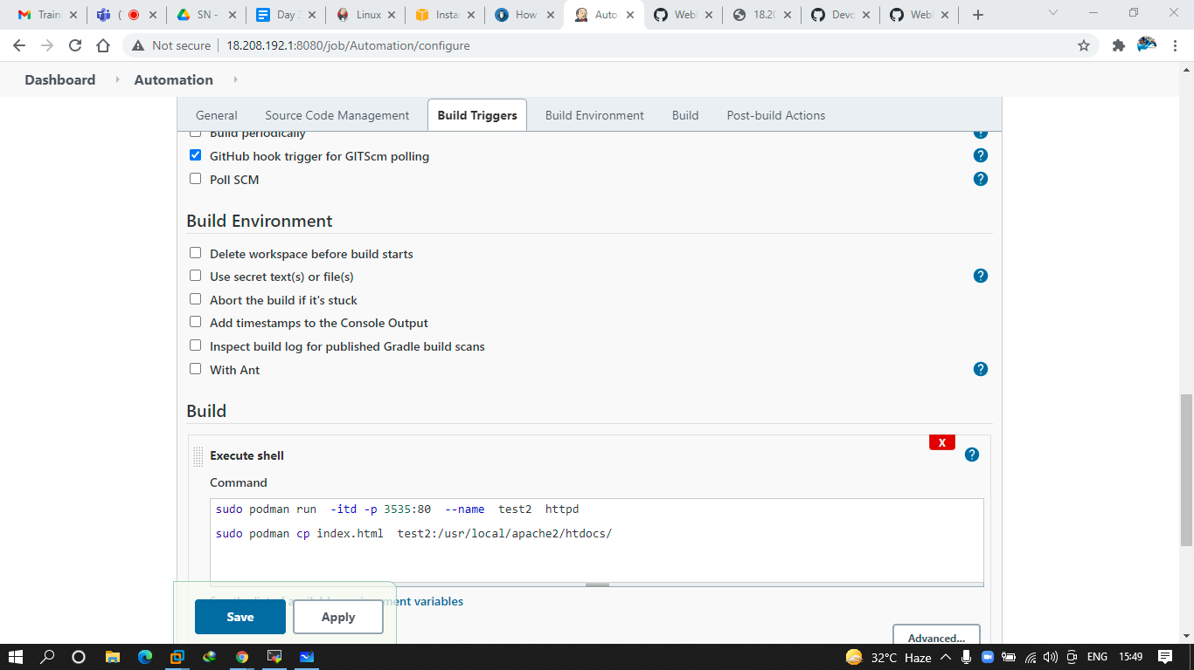

1 wget -O /etc/yum.repos.d/jenkins.repo https://pkg.jenkins.io/redhat-stable/jenkins.repo

2 yum install wget -y

3 wget -O /etc/yum.repos.d/jenkins.repo https://pkg.jenkins.io/redhat-stable/jenkins.repo

4 rpm --import https://pkg.jenkins.io/redhat-stable/jenkins.io.key

5 dnf install https://dl.fedoraproject.org/pub/epel/epel-release-latest-8.noarch.rpm

6 yum install epel-release java-11-openjdk-devel

7 yum install jenkins -y

8 systemctl status jenkins

9 systemctl start jenkins

10 cat /var/lib/jenkins/secrets/initialAdminPassword

11 systemctl status jenkins

12 vim /etc/sudoers

13 vi /etc/sudoers

14 yum install git -y

15 podman

16 yum install podman -y

17 podman info

18 podman images

19 podman ps

20 git clone https://github.com/mdhack0316/DevopsFISfiles

21 cd DevopsFISfiles/

22 ls

23 vim index.html

24 vi index.html

25 git add.

26 git add .

27 git commit -m "testing" .

28 git push

29 history

[root@ip-172-31-28-3 DevopsFISfiles]